**Task 6: Screen shots of Jira Tool for the Net Banking application**

**Creation of the project:**

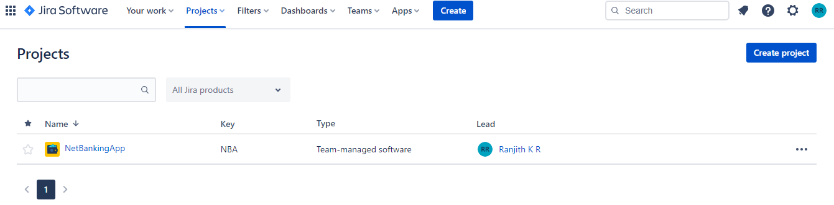

**Creation of Epic:**

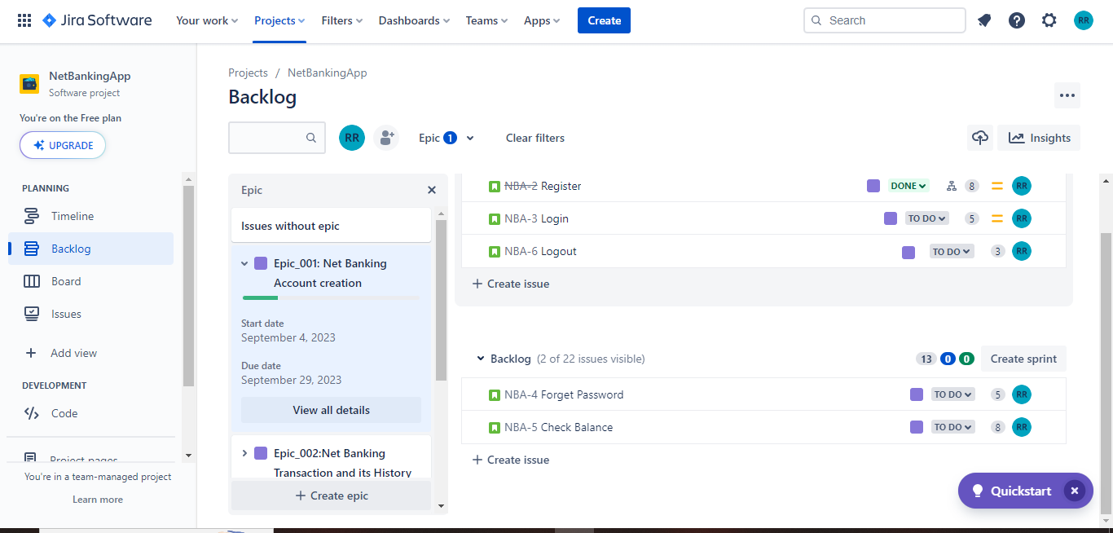

**Creation of stories**

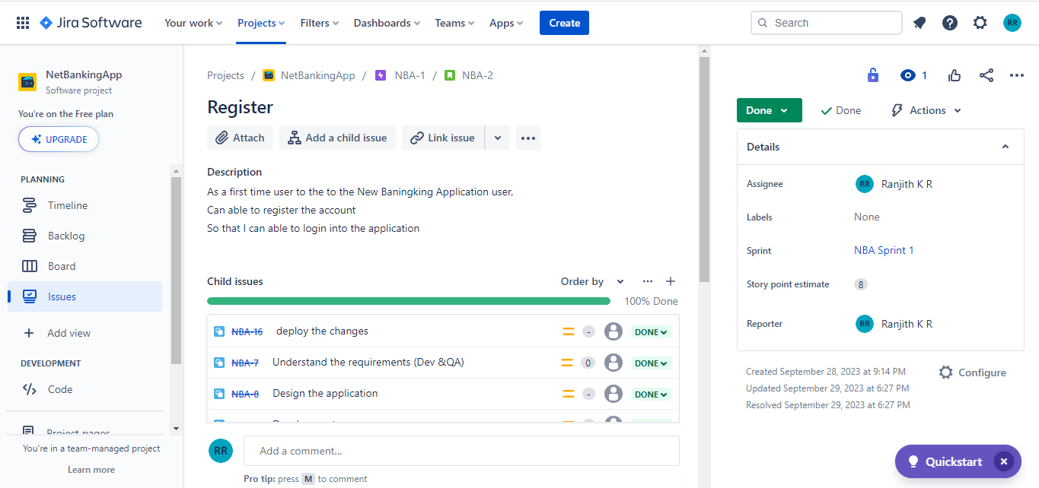

**Creation of story points or addition of Tasks:**

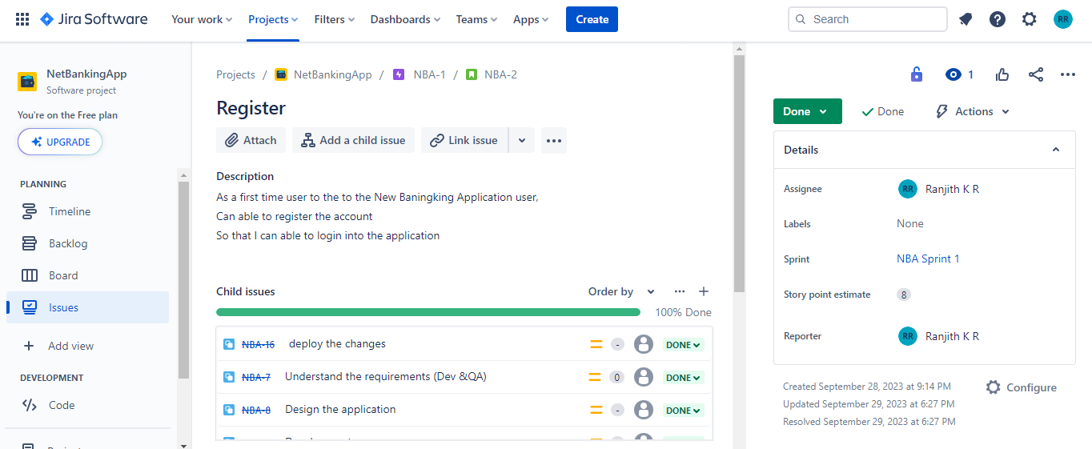

**Creation of Sprint:** 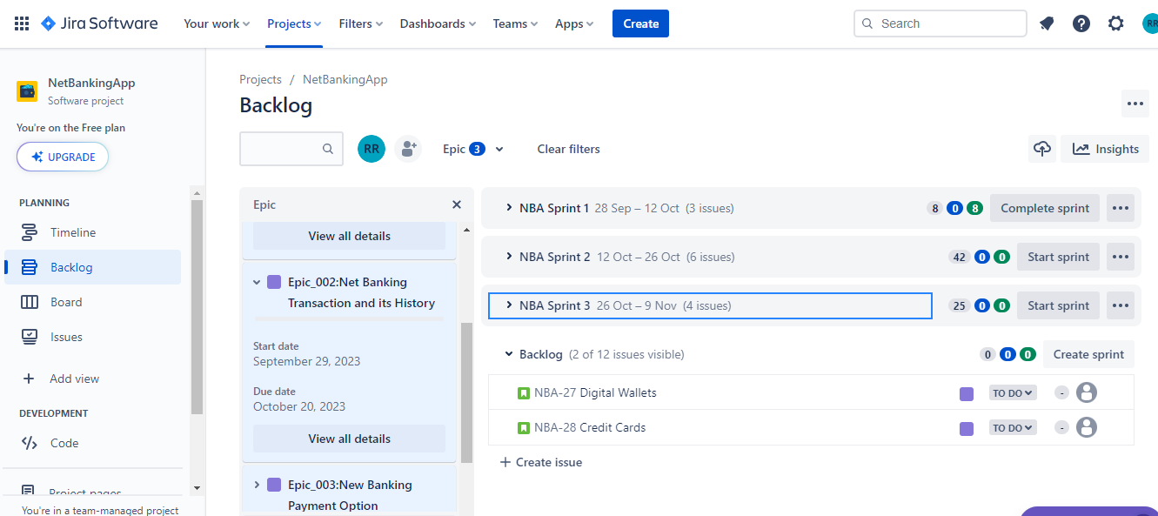

**Adding task to Sprint:**

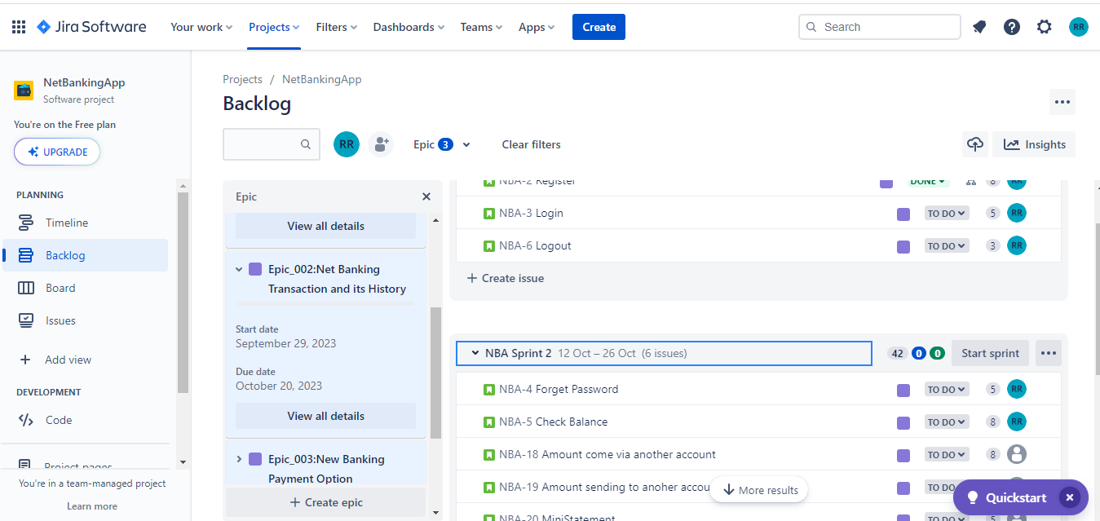

**Marking the task into the follow into Sprint Life cycle(todo,in progress,completed)**

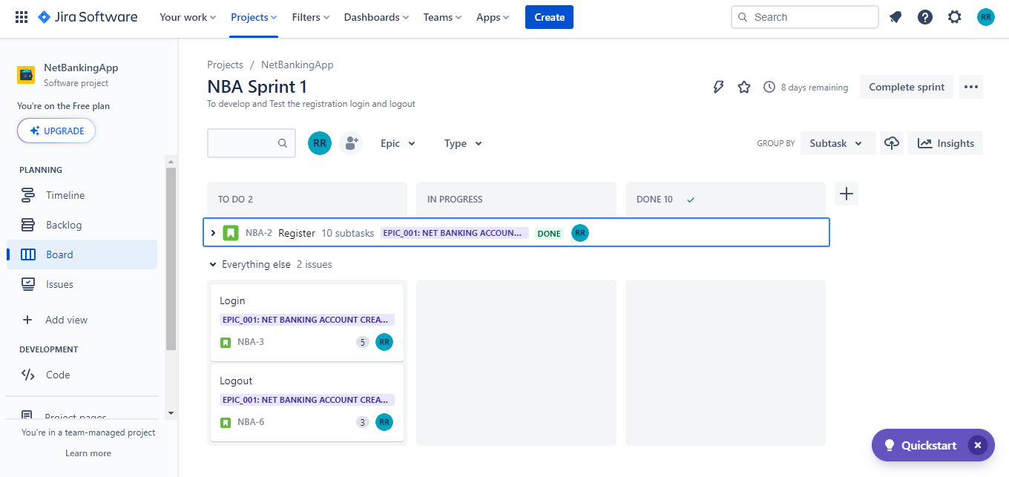

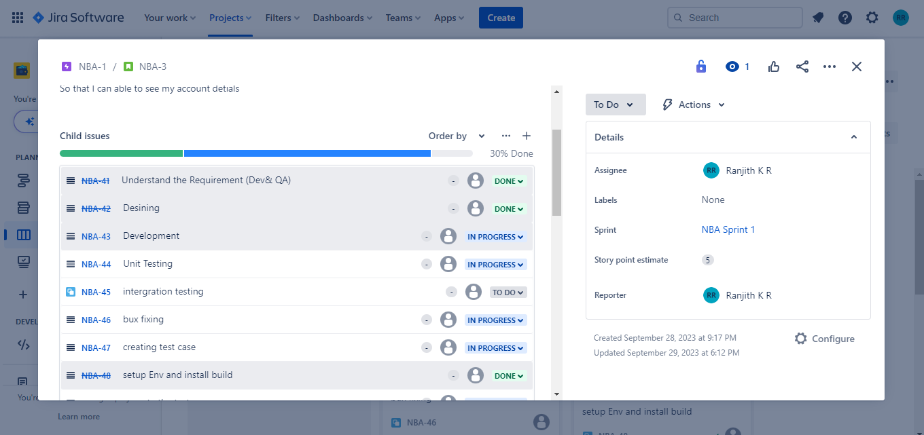

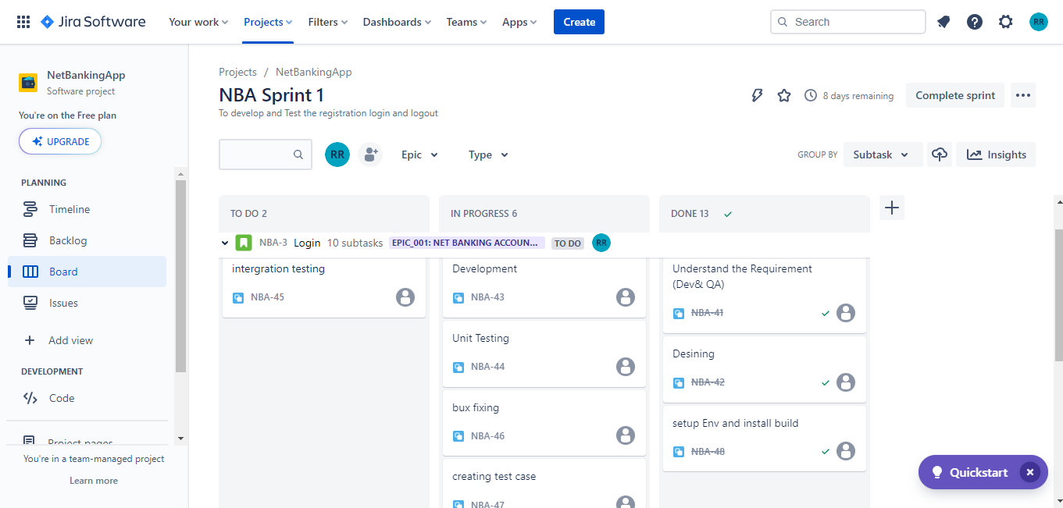

**Rasing bugs:**

